Hoang Minh Khue – Le Tran Bao Kien

S104221423 – s104223584

[mercury.swin.edu.au/cos30045/s104221423/WorldMigrationProject/](https://mercury.swin.edu.au/cos30045/s104221423/WorldMigrationProject/)

Team member: Hoang Minh Khue, Le Tran Bao Kien  
Tutor Date: Monday morning, 9 AM – 12 PM  
Spring 2024  
Word Count:

Global Migration Dynamics: Visualizing Patterns and Contexts

Table of Contents

1. Introduction 2

1.1. Background and Motivation 2

1.2. Visualization Purpose 2

1.3. Project Schedule 3

2. Data 4

2.1. Data Source 4

2.2. Data Processing 6

Hand Processing: 6

**World Bank( www.worldbank.org ):** 6

**United Nations ( www.un.org ):** 10

Code Processing: 13

Additional files: 15

3. Requirements 15

3.1. Must-have Features: 15

3.2. Optional Features: 15

4. Visualization Design: 16

4.1. Conceptualize (Design Iteration) stage: 17

4.2. Visualize Stage: 18

4.3. Materialize Stage: 20

4.4. Implementation Stage: 21

5. Final Design 24

6. Conclusion 25

References 26

# Introduction

## Background and Motivation

One of the key characteristics of human history has been migration, which has shaped civilizations, economies, and cultures on many continents and during many eras (Siddiqui, T., 2012). People have moved about throughout history as a necessary component of human existence, from the ancient nomadic tribes to the contemporary diasporas fueled by globalization. The topic of global migration has become increasingly important and well-known in the modern era due to a variety of causes, including political unrest, economic inequality, environmental damage, and climate change (Hammar, T., Brochmann, G., Tamas, K., & Faist, T. ,2021).

In a time of growing globalization and interconnection, the dynamics of human mobility are more intricate and nuanced than in the past. There are many different reasons why people move, such as to pursue better job prospects, further their education, be with family, or seek safety from persecution or violence (Castles, 2010). Furthermore, population movements are driven by environmental causes including natural catastrophes, environmental degradation, and climate change, which exacerbate already-existing vulnerabilities and inequities.

It is impossible to exaggerate the importance of the global migration issue in the modern world. As the number of individuals living in forced displacement reaches previously unheard-of heights, migration has become a significant humanitarian, social, political, and economic concern. It has significant ramifications for host communities, transit nations, and international geopolitics and has a significant impact on the rights and well-being of migrants (Faist, 2013). Furthermore, a wide range of other urgent challenges, including urbanization, sustainable development, labor markets, social cohesion, and human rights, are intertwined with migration (Castles, 2010).

## Visualization Purpose

It is becoming more and more necessary to visualize migration patterns and contexts due to the complexity and difficulties involved in global migration (Zambotti, G., Guan, W., & Gest, J. D. 2015) . A potent tool for deciphering the complex dynamics of migratory flows, exposing temporal and spatial trends, finding patterns and correlations, and locating underlying causes and effects is data visualization (Bertin, 2011). Visualization helps stakeholders, policymakers, scholars, and the public better understand the scope and complexity of migration phenomena by converting complex statistics into understandable and visually appealing representations (van Biljon, J., & Osei-Bryson, K. M. 2020).

Furthermore, migration data visualization acts as a catalyst for comprehending and resolving the underlying reasons and effects of migration (Sander, N., Abel, G. J., Bauer, R., & Schmidt, J. 2014). It offers insightful information about the geographic distribution of migrants, their travel routes and corridors, the demographics of migrant communities, and the social, economic, and environmental settings in which migration takes place. Equipped with such discernments, policymakers can devise empirically grounded tactics and measures to tackle the obstacles presented by migration, alleviate its adverse effects, and capitalize on its prospective advantages for both migrant populations and receiving communities.

To summarize, the visualization of migration patterns and contexts serves two purposes: first, it improves comprehension of the intricate dynamics of global migration; second, it provides guidance and information for policy and decision-making processes that aim to address the obstacles and maximize the benefits associated with human mobility. Through the effective use of visualization, we can shed light on the paths and histories of migration, give voice to the opinions and experiences of migrants, and help create more just inclusive, and sustainable societies in a global community that is becoming more interconnected by the day.

## Project Schedule

**Week 2-4: Project Kickoff and Data Collection**

* Define project objectives and scope.
* Assign roles and responsibilities within the team.
* Identify and gather relevant data sources on global migration.
* Begin initial exploration and assessment of the collected data.

**Week 5-6: Data Cleaning and Processing**

* Conduct thorough data cleaning to address missing values, inconsistencies, and outliers.
* Standardize data formats and ensure data compatibility.
* Perform any necessary data transformations or aggregations to prepare the data for visualization.

**Week 7-8: Design and Prototyping**

* Brainstorm visualization ideas and design concepts.
* Develop initial prototypes of visualization layouts and elements.
* Gather feedback from team members and stakeholders to refine the design.

**Week 9-10: Implementation**

* Translate finalized design concepts into code using chosen visualization tools or libraries.
* Integrate cleaned and processed data into the visualization.
* Conduct iterative testing and debugging to ensure functionality and usability.

**Week 11: Refinement and Evaluation**

* Fine-tune visual elements, layouts, and interactions based on user feedback.
* Conduct thorough testing of the completed visualization across different devices and browsers.
* Evaluate the effectiveness and usability of visualization in conveying migration patterns and contexts.

**Week 11-12: Documentation and Presentation**

* Compile comprehensive documentation of the project process, including data sources, cleaning and processing methods, design decisions, and implementation details.
* Prepare a final presentation summarizing key findings, insights, and implications of the visualization.
* Submit the completed project process book and present the visualization to the instructor and class.

# Data

## Data Source

The primary sources for raw data in this project are the World Bank (worldbank.org) and the United Nations (un.org). These reputable organizations provide comprehensive datasets related to global migration, offering insights into migration trends, demographic characteristics, and socio-economic contexts across countries and regions worldwide.

* **The World Bank (** [**www.worldbank.org**](http://www.worldbank.org) **)**:
  + The World Bank offers a wealth of demographic and socio-economic data, including information on international migration patterns, immigrant populations, and migration-related variables such as country of birth, citizenship status, and migration flows. Data from the World Bank's Migration and Remittances dataset and other sources provide valuable insights into migration trends within countries and globally.
  + **Data Set 1**: Life Expectancy data from the World Bank's World Development Indicators dataset.
    1. **Data Type**: The data set includes the following variables:
       1. Country Name (Categorical)
       2. Life Expectancy (Quantitative)
  + **Data Set 2:** GDP per Capita data from the World Bank's World Development Indicators dataset.
    1. **Data Type:** The data set includes the following variables:
       1. Country Name (Categorical)
       2. GDP per Capita (Quantitative)
  + **Data Set 3:** Population data from the World Bank's World Development Indicators dataset.
    1. **Data Type:** The data set includes the following variables:
       1. Country Name (Categorical)
       2. Population (Quantitative)
  + **File Type**: Raw data obtained in .csv format.
* **United Nations (** [**www.un.org**](http://www.un.org) **)**:
  + The United Nations is a leading source of data and research on global migration, providing comprehensive statistics and analyses on international migration trends, refugee movements, asylum seekers, internally displaced persons (IDPs), and other migration-related topics. Datasets from UN agencies such as the International Organization for Migration (IOM), the United Nations High Commissioner for Refugees (UNHCR), and the United Nations Department of Economic and Social Affairs (UN DESA) offer valuable insights into the scale, dynamics, and impacts of migration worldwide.
  + **Data Set**: Global Migration Statistics from the United Nations
  + **Data Type**: The data set includes the following variables:
    1. Country Name (Categorical)
    2. Number of Immigration People (Quantitative)
  + **File Type**: Raw data obtained in .xlsx format, converted to .csv format using [www.cloudconvert.com/xlsx-to-csv](http://www.cloudconvert.com/xlsx-to-csv) website.

These two main data sources serve as foundational pillars for this project, providing reliable and authoritative data that underpins the visualization of global migration patterns and contexts. Additional supplementary data sources may be explored to enrich the analysis and address specific research questions or objectives identified during the project's development.

## Data Processing

### Hand Processing:

Although the datasets obtained from the organizations guarantee high integrity and timeliness, data cleaning and reorganization are essential to achieve the desired level of "conformity" necessary for visualization in D3.js. The data processing procedure involves distinct steps for each of the retrieved datasets, as each one necessitates pruning, pivoting, and aggregating to a certain degree. Once the design selection is finalized, the dataset will be further filtered to align with the specifications of the data visualization design, marking the milestone of "conformity" and indicating that the data is prepared for visualization.

## **World Bank(** [**www.worldbank.org**](http://www.worldbank.org) **):**

The original data is structured as a CSV (Comma-Separated Values) file, with the first dataset for **Life Expectancy** containing rows representing different countries or regions and columns representing attributes such as the name of the country, country code, indicator (in this case, life expectancy at birth), and numerical values indicating life expectancy for each year. The second dataset was for **GDP per capita (Current US$)**, in which each row represents a country, and the columns include the country name, country code, indicator name (GDP per capita), indicator code, and GDP per capita values for different years. The years range from at least 1960 to 2022, with missing data represented by empty fields. The final dataset from the World Bank is for the **Total Population** data. Each row represents a country or region, with columns indicating the name of the country or region, the country code, the type of data (in this case, total population), and population values for different years. The years from 1960 to a more recent year, likely reflect the most up-to-date available data. The population values are in numeric format. Additionally, there are rows representing aggregates such as "World" and "Upper middle income.". The following three figures depict the three original datasets downloaded from the World Bank.

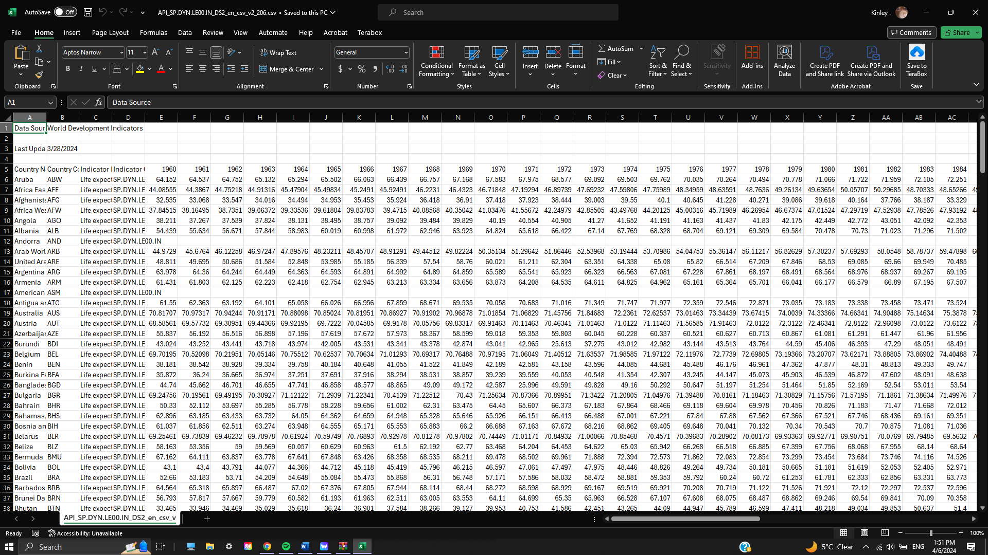

Figure : Life expectancy at birth from worldbank.org

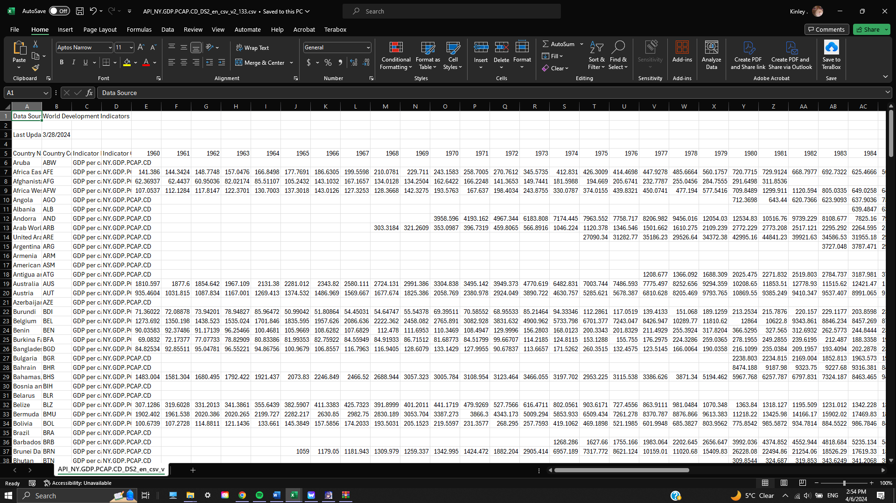

Figure : GDP per capita (current US$) from worldbank.org

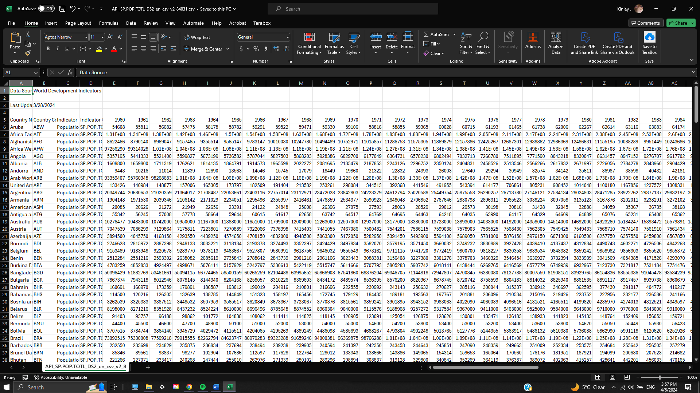

Figure : Population, total from worldbank.org

The first step of cleaning is to remove unnecessary rows and columns that do not contain important information needed for the visualization. This process was done by hand since all three files only contain a single table, and by cleaning and renaming the file to *WB_LifeExpect.csv*, *GDP.csv*, and *Population.csv* respectively, we can better handle the file here on out. Figures 3, 4, and 5 depict the aforementioned.

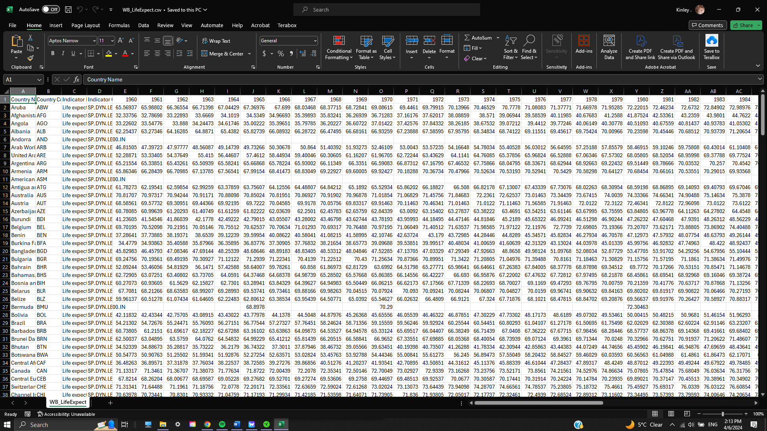

Figure : Life expectancy data after cleaning by hand

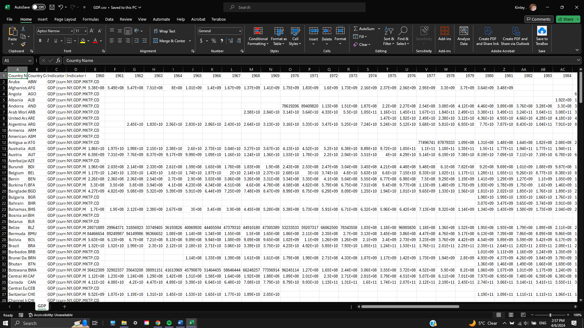

Figure : GDP per capita data after cleaning by hand

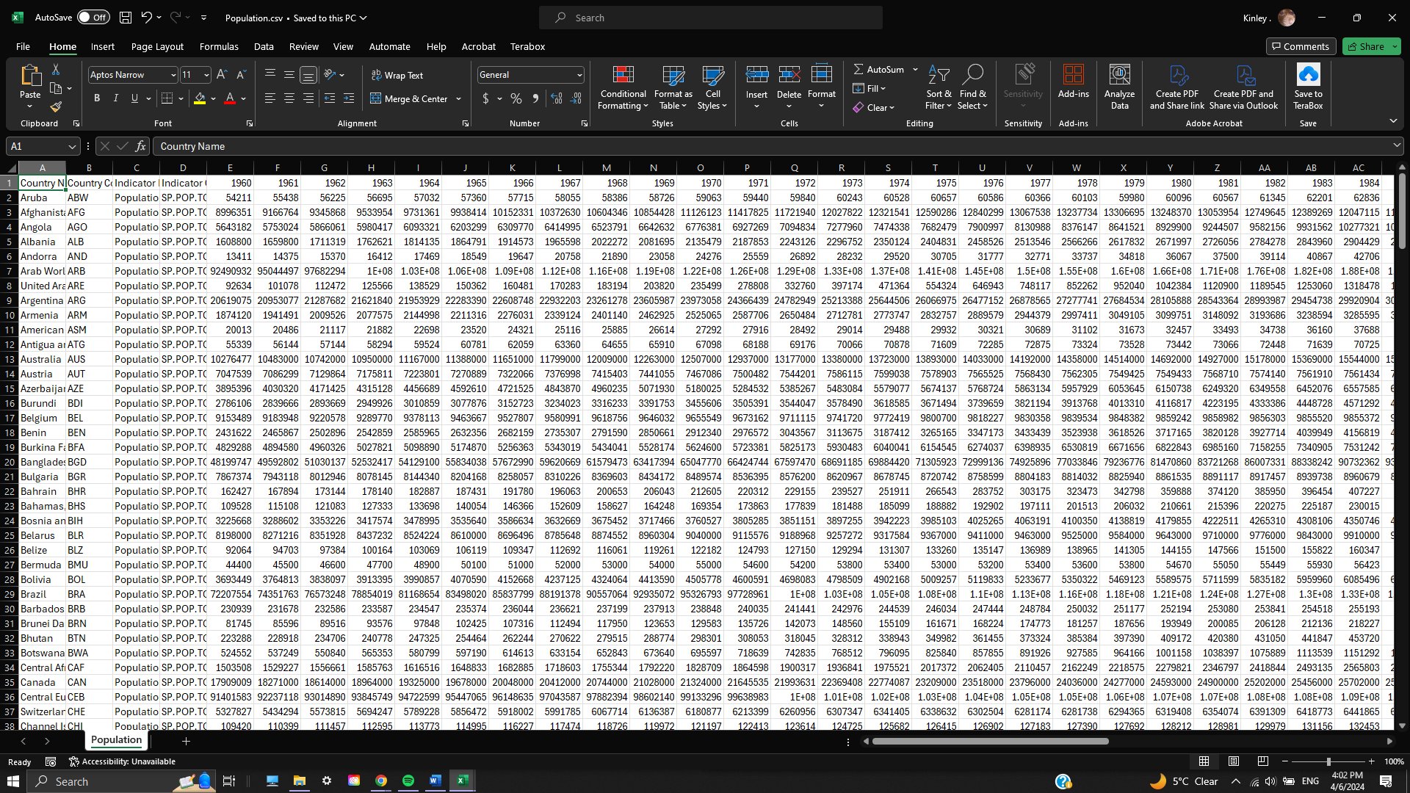

Figure : Total population data after cleaning by hand

## **United Nations (** [**www.un.org**](http://www.un.org) **):**

Different from the dataset gathered from the World Bank, the original data from the United Nations is structured as an XLSX (Microsoft Excel Open XML Format Spreadsheet) file, with multiple tables each representing a different dataset. The following figure depicts the original data downloaded from the United Nations.

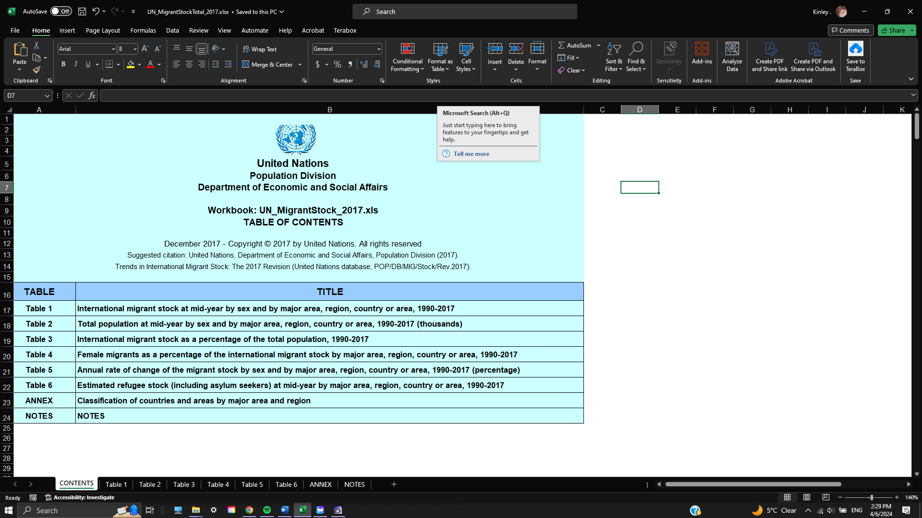

Figure : Raw data file downloaded from UN

With the first step of making the dataset usable for our project, the file needs to be converted to a CSV format. By using a web-based application called “cloudconvert” ([www.cloudconvert.com/csv-to-xlsx](http://www.cloudconvert.com/csv-to-xlsx) ), we were able to obtain the required file. Based on the above figure, the file contains multiple tables, each representing an aspect of immigrant and emigrant when being considered for comparison between countries. This was an obstacle for us when trying to process the data. Instead of processing the whole file, we decided to pick out the tables that held information that was crucial to the aim of the visualization. The table we have chosen is Table 1 ( International migrant stock at mid-year by sex and by major area, region, country, or area, 1990 – 2017). With the process of handling the dataset by hand, we have split the said table into different files, with each name containing the format “*Migrate_XXXX.xlsx*” where “XXXX” corresponds to each respective year. The original Table 1 is as follows:

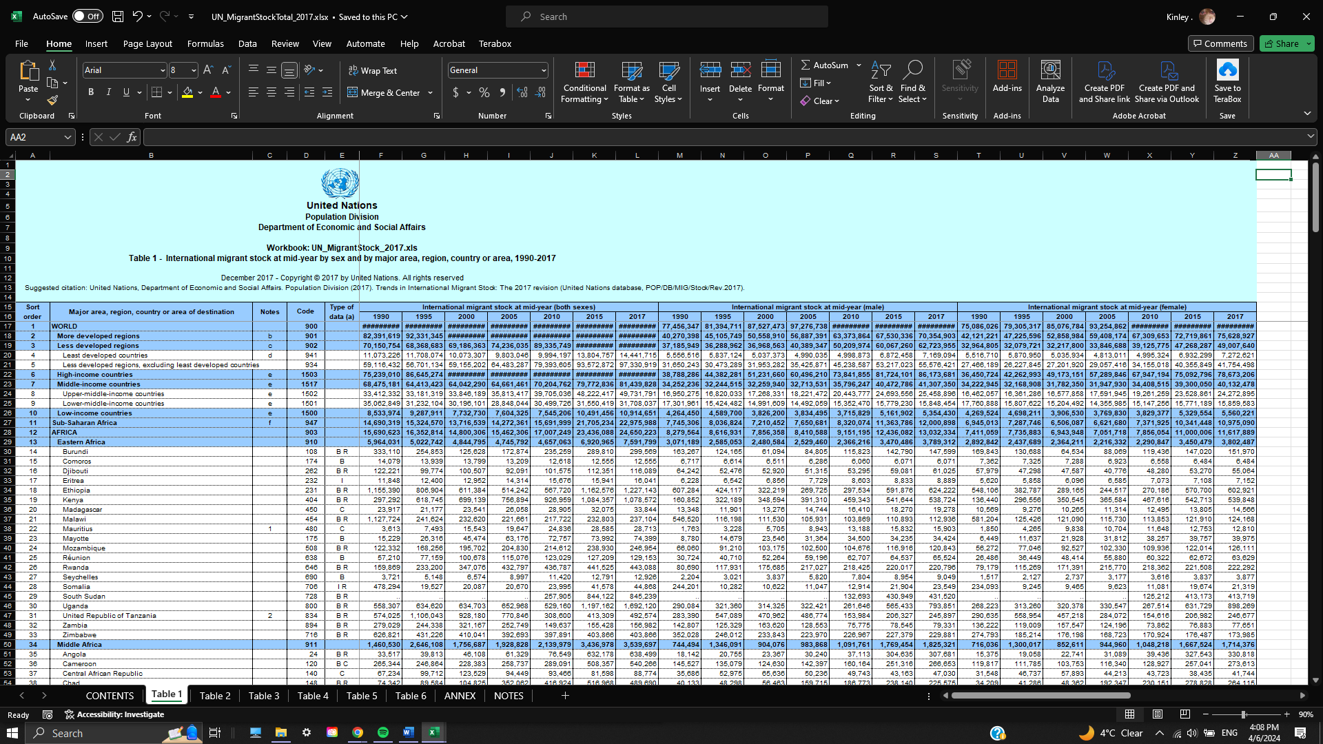

Figure : The original Table 1 from the UN dataset

After the process of hand-cleaning data for table 1, we have the following files:

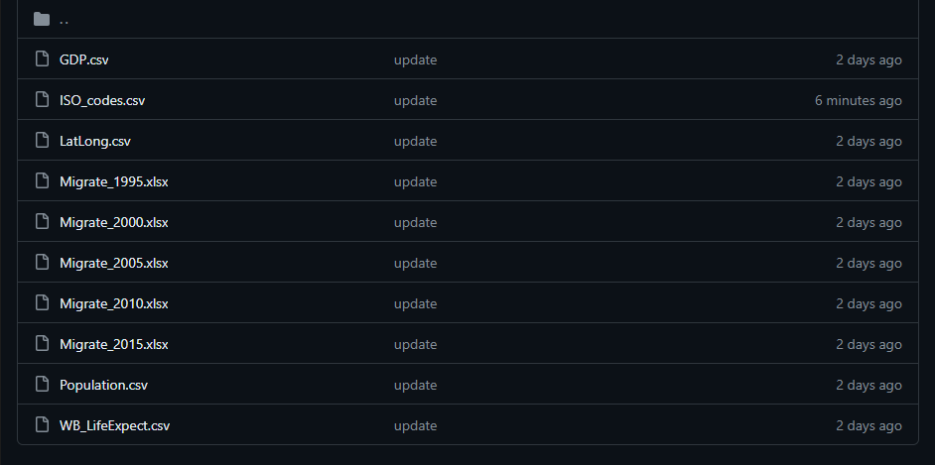

Figure : Split the table mentioned above into different files

Each of these files has the same format, with the only difference between each one being the year they represent. For example, the following figure is a representation of the format, more specifically the file “*Migrate_2000.csv*”.

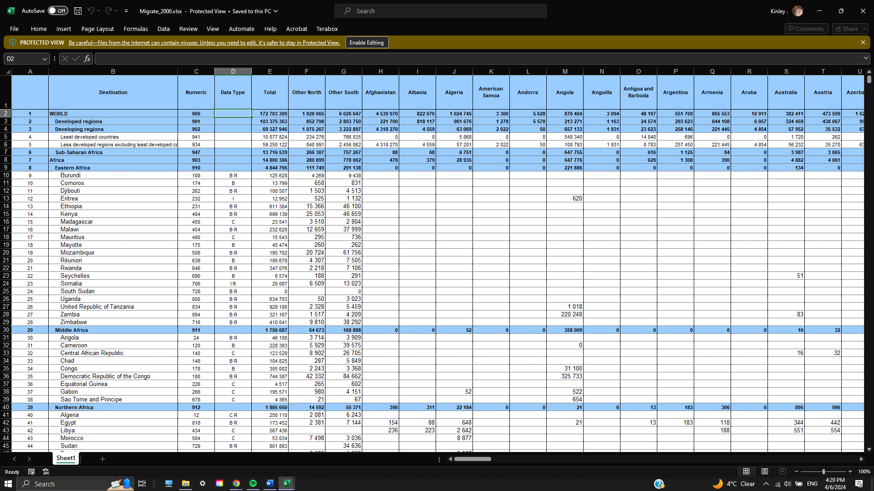

Figure : Migrate_2000.csv example

All the “Migrate_XXXX.xlsx” was formatted the same for ease of use and cleaner data representation.

### Code Processing:

With each of the previously hand-processed data files, we put them into the same directory called “raw_data” for ease of navigation and differentiation. All the previous files were not suitable for generating a visualization, so we had to come up with a Python-based program to help us process the data better and faster. The code can be explained as the following:

1. Data Processing: The program reads and processes various demographic and economic data from different sources, including data related to countries, population, life expectancy, GDP, and migration.
2. Statistical Calculations: The program calculates various statistics related to migration, such as positive and negative stock, net migration, and immigration fraction.
3. Data Output: After processing and analyzing the data, the program outputs the results into structured formats, including JSON and CSV files, which can be used for further analysis, visualization, or integration with other systems.

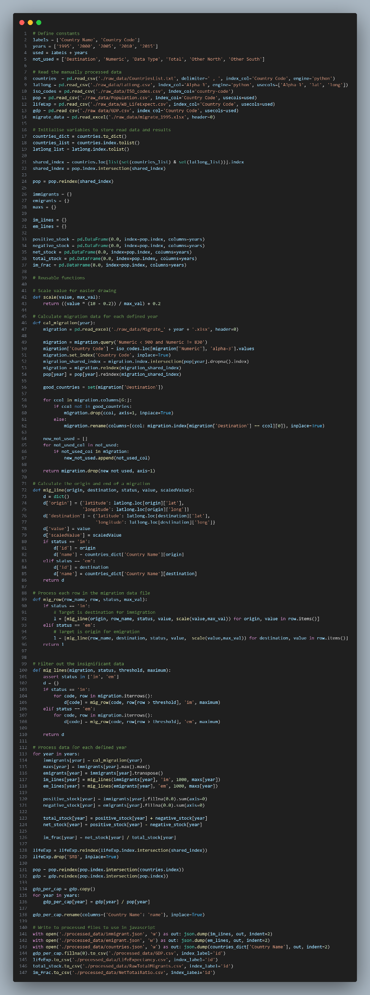

Figure : Python-based program for data cleaning

### Additional files:

Apart from all the above dataset files, two more were considered to be crucial during the process of creating the visualizations: *ISO_codes.csv* and *LatLong.csv.*

# Requirements

## Must-have Features:

**Interactive Visualization:**

1. Hover Effect:

* Implemented the world map to display detailed data and explanations when hovering over specific countries or regions.
* Added to the map to highlight migration pathways and showcase detailed data.

1. Drill-Down:
   * Different description box tabs are shown when clicking on specific countries, providing a How-to-read section and a summary/background section. Additionally, a detailed data table is displayed.
2. Selectors:
   * Implemented the world map, allowing users to select a country and view migration patterns to and from that country.

**Additional Information:**

* Providing ample context is crucial for visualization understanding, so we provide additional labeling.

**Clear Data Labeling:**

* Ensures users grasp the represented data.

**Color Contrast:**

* Different colors represent distinct migration flows, aiding readers' visual clarity.

## Optional Features:

**Tooltip Integration:**

Tooltips offer instant context, eliminating the need to memorize information. While this functionality couldn't be implemented, an alternative has been provided to serve a similar purpose.

# Visualization Design:

We structure our visualization design process into four stages, each applicable to both initial development and refinement. These stages are as follows:

1. **Conceptualize**:

* Brainstorming & Sketching: Generate rough ideas based on project goals and data. This includes sketching layouts, exploring visual elements (maps, charts, graphs), and storytelling approaches.
* Research & Inspiration: Analyze existing migration visualizations to learn from best practices.
* Target Audience: Consider user needs (policymakers, researchers, public) for effective communication.
* Technical Feasibility: Evaluate visualization techniques considering data complexity, performance, and resources.

1. **Visualize**:

* Refine Sketches: Polish initial sketches based on feedback, using design software or prototyping tools.
* Prototype Layouts: Develop layouts balancing visual appeal and functionality. Experiment with data element arrangement, scales, and annotations.
* Color Palette & Style: Explore color schemes, typography, and graphic styles for a cohesive and engaging presentation. Apply color theory for readability and meaning.

1. **Materialize:**

* Finalize Design: Make final decisions on styling, colors, and additional visual elements. Create a style guide for consistency.
* Iterate on Feedback: Refine based on usability testing and user research, ensuring accessibility for diverse users.
* Interactive Elements: Consider tooltips, filters, and animations to enhance engagement and exploration. Design intuitive navigation to guide users.

1. **Implementation**:

* Coding the Design: Translate final design concepts into code using appropriate libraries (d3.js).
* Data Integration: Integrate cleaned and processed data, ensuring accuracy and relevance. Use data-driven visual encoding techniques (size, color, position).
* Testing & Debugging: Conduct thorough testing to identify and resolve technical issues or compatibility concerns. Test across devices, screen sizes, and browsers.
* Iterative Changes: Propose changes based on usability testing to optimize engagement and comprehension. Document the implementation process for future updates and maintenance.

## Conceptualize (Design Iteration) stage:

We want to offer a straightforward, interactive layout in the first early stages of the visualization design process that will work for the public, who is our target audience. We adopt distinct approaches to various visualizations while working with classified sorted data, all the while maintaining consistency to guarantee a user-friendly experience.

Without thoroughly reviewing the data we have discovered, we created a rough sketch for the first visualization, Migration Pattern, to convey our ideas to the reader. We concentrated on "World Map" style visualizations and carefully considered our options because our goal is to visualize the flow of immigrants and emigrants from different countries to one another.

The figure below is our attempt to implement a “World Map” visualization, which in our opinion, was the go-to way to help users grasp the concept of Immigrant and Emigrant flows relative to countries all over the world.

Figure : An Attempt at the world map sketch

Throughout our research, we have found other visualization alternatives but mostly aren’t suitable for the scope our project is going for. A bar chart is a great implementation of a visualization to describe the flow of immigrations and emigrations over time. Still, sadly that’s only applicable for a single country for each country, since implementing for all countries over the world can make a bar chart seem inadequate when the user wants to compare between countries. Instead, we have chosen the Bar Chart as a supporting visualization for the main one, i.e. the World Map above. Another type of supporting visualization we decided to implement was a Pie Chart, for which the goal was to visualize the men and women percentage in immigrating or emigrating between countries.

## Visualize Stage:

We now produce a set of higher fidelity designs after looking into our design decisions, which aids in contextualizing the idea behind these visualizations. We would like to see a justified, centered look at the Migration Pattern visualization, with different sections representing different rates of immigration and emigration.

Figure : First iteration of the world map

The figure depicts our first iteration of a World Map. The key feature is the clear delineation of countries by black borders. There's no indication of country labels or other details on this specific screenshot, and the scale isn't evident, making it difficult to gauge the relative size of different regions. However, this map serves as a simple yet informative way to visualize the Earth's landmasses divided into individual nations. There is no additional information about the World Migration Project on the screenshot. It is unclear what the purpose of the website is, or what kind of information it provides about migration.

With these ideas in mind, a mockup for the website was made by me in an Excel sheet to gather feedback from the lecturer, Dr Hoang Xuan Tung. We made suggestions on how to implement the GDP per Capita data into the visualization to help users better understand the correlation between the immigration/emigration rate and how the GDP of a country can affect those numbers. We have chosen a side-to-side Pie Chart depicted in the figure below, to help users compare developing and developed countries. It would contain the percentage of men and women when immigrating or emigrating, and the user can specify which country to visualize.

Figure : mockup design of the website

After receiving feedback from Dr. Hoang Xuan Tung, we have decided to implement a color system within the World Map to display the GDP per capita, making the two Pie charts below the main visualization redundant. This will be further elaborated in the next section of this report.

Figure 14: second iteration of the world map

With suggestions from Dr. Hoang Xuan Tung, the idea was to use a single World Map to display the flow of immigration and emigration using colored lines, flowing in or out of a selected country. Options are displayed at the top-left of the World Map to prompt the users between viewing the immigrant flow, which would be represented by a curved line flowing in from other countries, with the emigrant being represented in the same way. At this stage, we were still working on a simple way of showing the difference between the in-flow of immigrants and the out-flow of immigrants. A simple color scale between red and green was used to represent the differences in **GDP per capita**, and **Life expectancy**. However, there was a problem as our team felt the lack of supporting charts, as the website lacked basic information about the said World Map, so we were prompted to raise concerns during the next Stand-Up meeting.

## Materialize Stage:

Between the two Stand-Up meetings 2 and 3, our team was able to add additional user controls to help navigate the world map, while changing the color scale to better represent the changes in the data ( i.e. GDP per capita and Life expectancy). The result was the following figure.

Figure : Third iteration of the world map

With Stand-Up Meeting 3 coming to an end, we decided to add another supporting visualization, a simple line graph that shows the net immigrant/emigrant rate of a country. With the idea of helping the users grasp the concept of immigrant and emigrant better, we feel that the said supporting visualization would provide ample support, displaying numbers that help users to conceive the flow of immigrants and emigrants better from the World Map alone.

## Implementation Stage:

Figure : fourth iteration of the world map

The final design for our Stand-Up Meeting 4 is displayed above, with almost every feature we aim to create, the map contains everything needed for a user to navigate and use the World Map effectively. The newly implemented user interface showcases a Migration Data showcase of selected countries, which would display every country immigrating or emigrating relative to the selected country.

Figure : Example of the new user interface ( U.S.A. in 1995 )

With the previously mentioned supporting visualization, we have found a way to implement it. By selecting a country on the World Map, a second visualization will appear beneath the World Map. This visualization aims to help users understand more about the numbers of immigrants compared to emigrants of a country.

Figure : Example of the supporting visualization ( U.S.A. in 1995)

With the final product completed, we felt the need to help users find countries easier, since for some, locating countries through geographical is not an easy task, so we opted to implement a search bar function, to help users find specific countries.

Figure : Implementation of the search function, Final iteration of the world map

# Final Design

The final version of our data visualization set is shown below; you can also view it by clicking the provided Mercury link ( [mercury.swin.edu.au/cos30045/s104221423/WorldMigrationProject/](https://mercury.swin.edu.au/cos30045/s104223584/Lab08) ).

Figure : Final design of the website 1

Figure : Final design of the website 2

# Validation

In addition, the user experience validation phase was conducted to gather valuable insights and feedback from participants regarding the usability and effectiveness of the visualization on global migration, life expectancy, and GDP per capita. A total of 24 participants took part in the user test, representing a diverse range of backgrounds and expertise. This section presents the findings and analysis of the user test, focusing on the participants' experiences, observations, and recommendations. The validation process aims to ensure that the visualization meets the needs of its intended user and provides an engaging and informative user experience. The insights gained from this phase can lead to further improvements of the overall usability and effectiveness of our project.

The following is a list of the questions that I asked in the form:

* The user’s experience with UI/UX and Data Visualization:
  + What is your experience with UI/UX and design patterns? (scale 0 - 10)
  + What is your experience with Data Visualization? (scale 0 - 10)
* The user’s experience with our project:
  + How intuitive was it to interact with the visualization? (scale 0 - 10)
  + Which features or functionalities of the visualization did you find most useful or engaging? (select boxes)
  + Which features or functionalities of the visualization did you find most useless? (select boxes)
  + How engaging is the visualization? (scale 0 – 10)
  + Were there any features or functionalities that you felt were missing or could be improved? (text entry)
  + To what extent does the visualization answer your question regarding the world migration topic? (scale 0 – 10)
  + Did the visualization effectively convey the global migration trends and their relationship with life expectancy and GDP per capita? (Yes – No)
  + On a scale of 1 to 5, how would you rate the overall usability of the visualization? (scale 1 - 5)
  + On a scale of 1 to 5, how visually appealing did you find the visualization? (scale 1 – 5)
  + Would you recommend this visualization to others? (Yes – No)

## Participants’ experience with UI/UX and Data Visualization

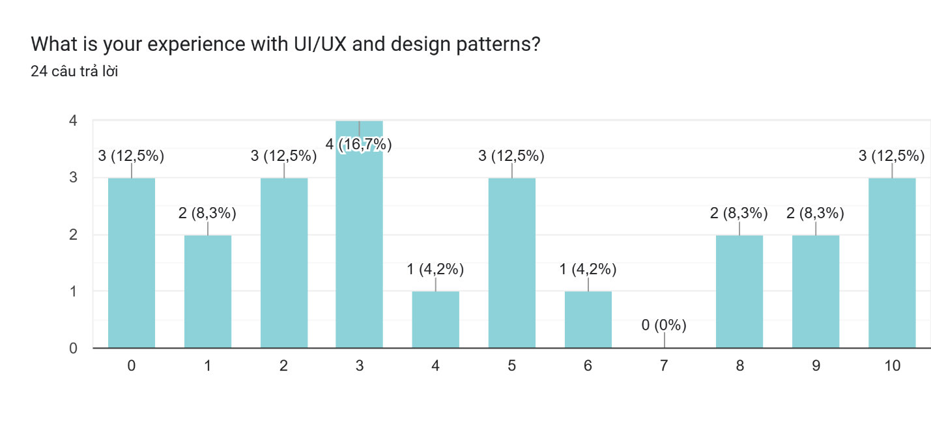

Figure 22: Users’ experience with UI/UX response

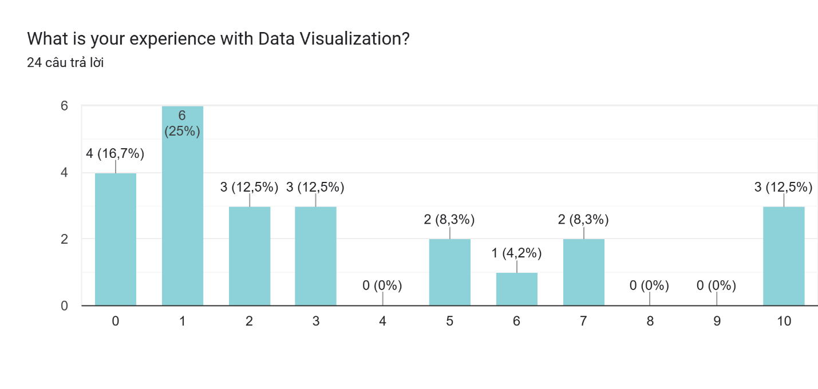

Figure 23: Users’ experience with Data Visualiztion response

It can be observed that a significant portion of the participants indicated a relatively low level of familiarity with both UI/UX and data visualization. For UI/UX and design patterns, 12.5% of the participants reported a score of 0, indicating no prior experience in this domain. Similarly, for data visualization, 16.7% of the participants reported a score of 0, indicating no previous exposure to data visualization concepts. These findings suggest that the majority of participants are relatively unfamiliar with UI/UX principles and data visualization techniques. It is important to consider this limited familiarity when interpreting their feedback and recommendations. The insights provided by these participants can offer an unbiased perspective and highlight areas where the visualization can be improved to cater to users with diverse levels of expertise.

These varying levels of experience with UI/UX, design patterns, and data visualization will provide valuable context when analyzing the participants' feedback on the usability and effectiveness of the visualization. The insights gained from individuals with different backgrounds and expertise will contribute to a comprehensive understanding of the user experience and guide improvements in the visualization's design and functionality.

## Participants’ experience with our project

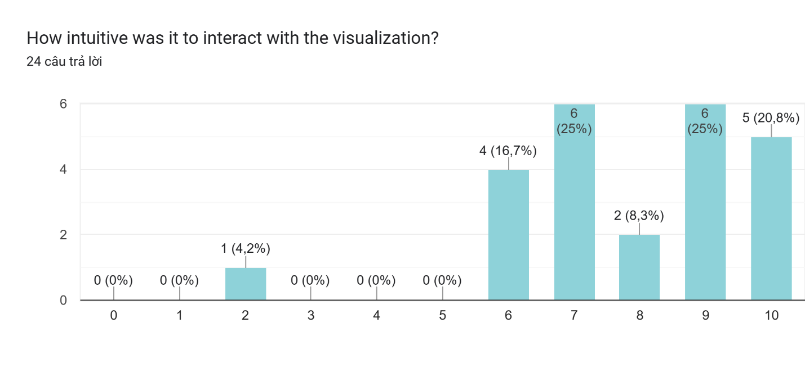

Figure 24: Users’ response to intuitiveness of the project

The responses received for the question "How intuitive was it to interact with the visualization?” indicate that a majority of participants found the interaction with the visualization to be relatively intuitive, with ratings ranging from 6 to 10. However, it is worth noting that a small percentage of participants did not find the interaction to be intuitive, as they didn't provide ratings in the higher range. This suggests that there may be room for improvement in terms of enhancing the overall intuitiveness of the visualization's interaction design.

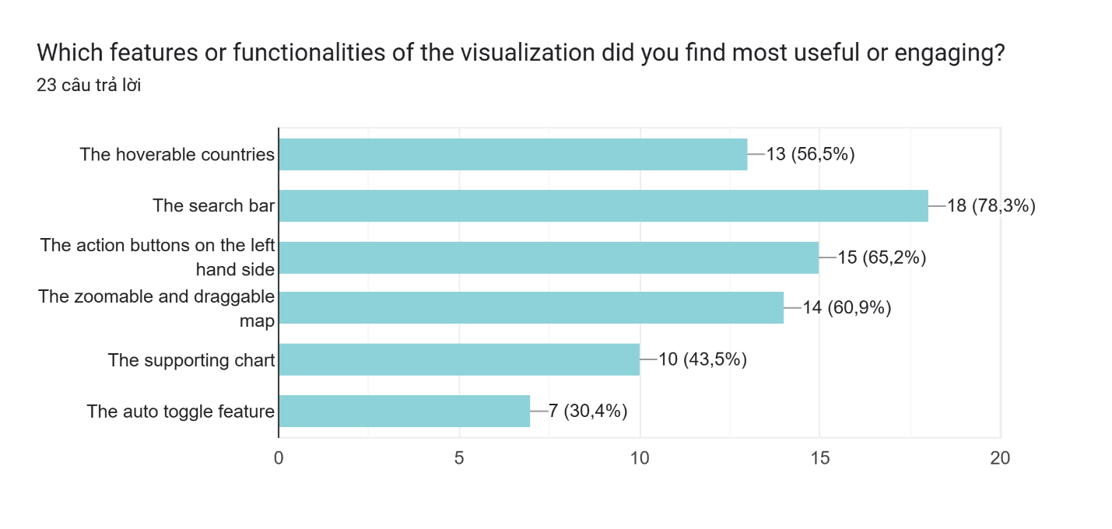 Figure 25: Users’ response to useful features

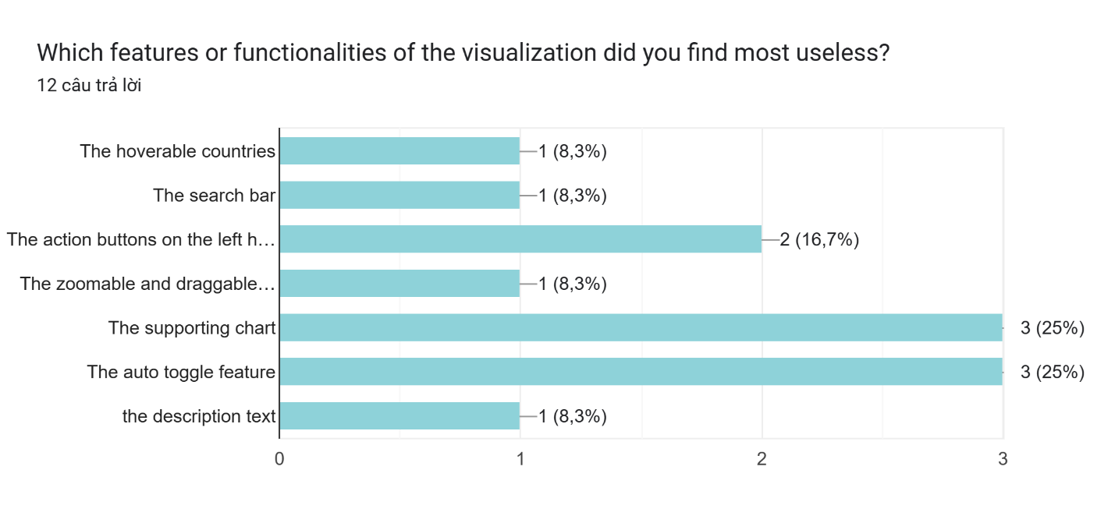

Figure 26: Users’ response to useless features

23 responses received for the question "Which features or functionalities of the visualization did you find most useful or engaging?" highlight the features that resonated most with the participants. The majority found the " search bar " feature engaging, indicating its effectiveness in capturing users' attention. The " hoverable countries " and "action buttons" were considered useful by a significant percentage, suggesting their contribution to the overall functionality of the visualization. The "zoomable and draggable map" feature attracted the interest of a majority of participants, while the "supporting chart" was found useful by a considerable proportion. However, the "auto toggle feature" did not generate as much engagement as the other features.

Only 12 responses for the opposite question which suggest that a small percentage of participants did not find certain features of the visualization to be useful. The "supporting chart" and "auto toggle feature" received a higher percentage of respondents considering them useless, while other features had relatively lower percentages. It's important to note that these opinions represent the views of a subset of participants and may not reflect the overall user sentiment.

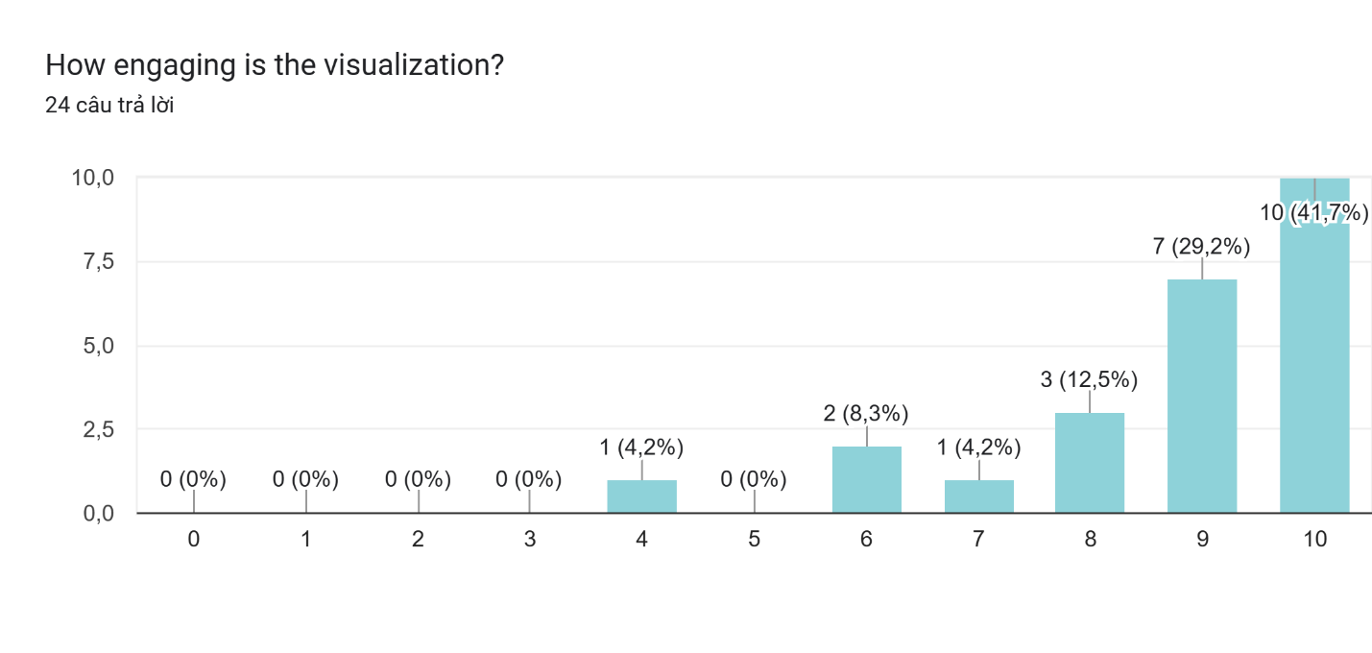 Figure 27: Users’ response to engagement

Based on the responses received for the question "How engaging is the visualization?", it is clear that the majority of participants found the visualization to be highly engaging, with a significant percentage giving it a rating of 9 or 10. Ratings from 6 to 8 were less common, while lower ratings (4 and below) were provided by a smaller percentage of participants.

For the question “Were there any features or functionalities that you felt were missing or could be improved?”, there are 2 valid suggestions. One states that the coloring of our visualization should be improved and the other says that we should include more numeric detail for the migration data.

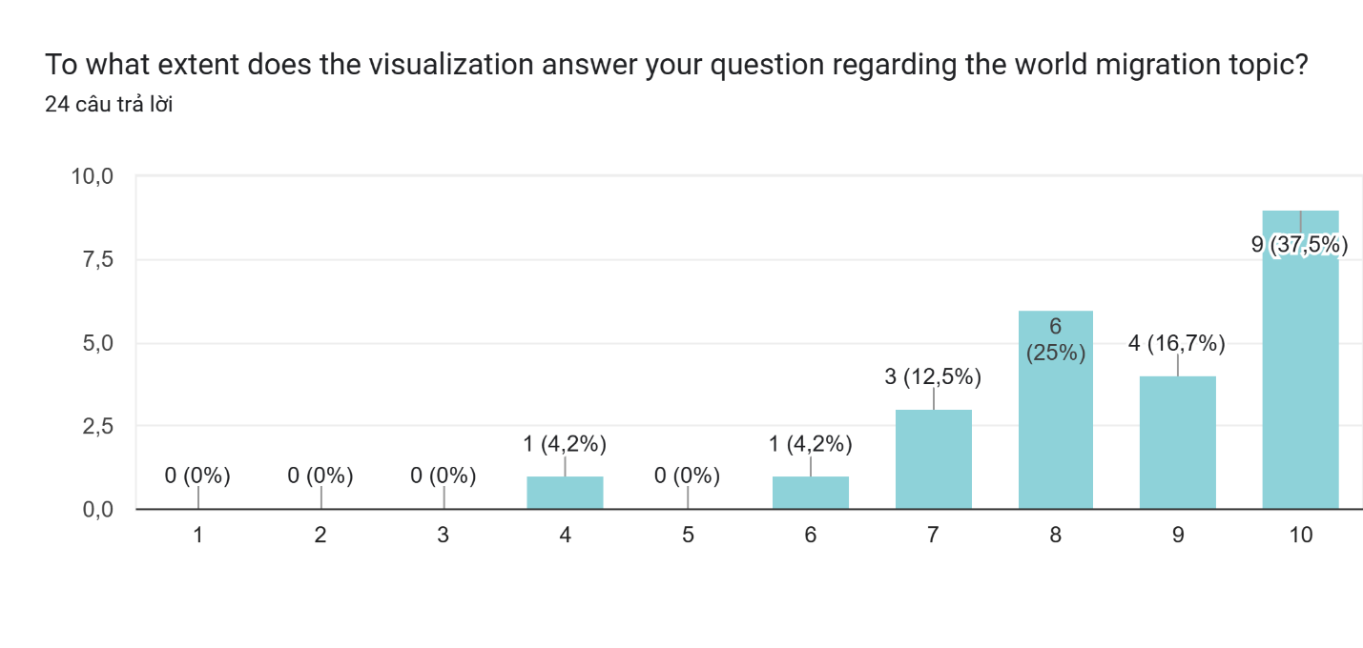

Figure 27: Users’ response to informativeness

The responses to the question “To what extent does the visualization answer your question regarding the world migration topic?” indicate that the majority of participants found that the visualization effectively answered their questions regarding the world migration topic. A significant percentage rated it as 9 or 10, indicating a high level of satisfaction with the visualization's ability to address their queries. Ratings of 7 and 8 were also relatively common, while lower ratings (4 and 6) were provided by a smaller percentage of participants.

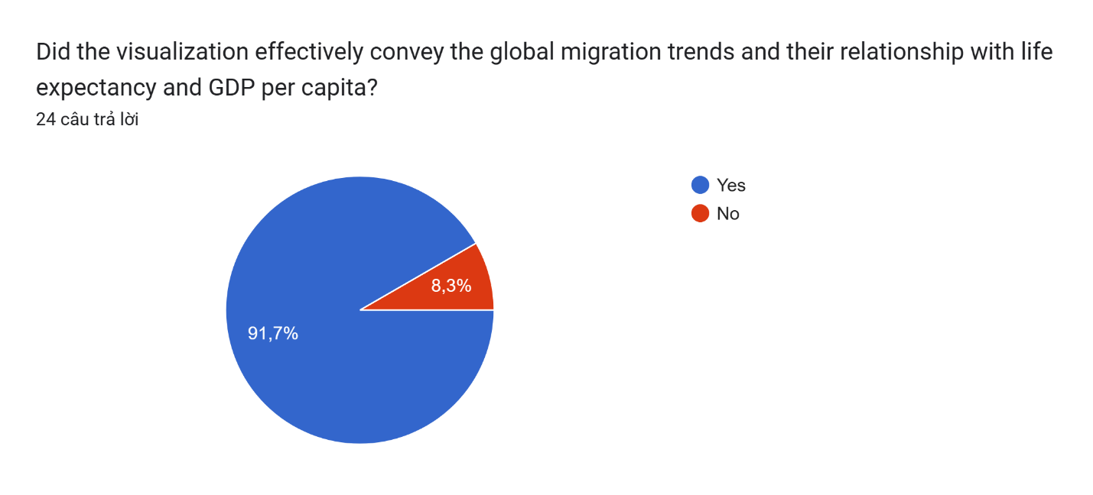

Figure 28: Users’ response to relations between data

The feedback indicates that the visualization was successful in effectively conveying the global migration trends and their relationship with life expectancy and GDP per capita for the majority of participants. The high percentage of participants who answered "YES" suggests that the visualization provided clear and understandable information, allowing users to grasp the connections between migration, life expectancy, and GDP per capita. However, it's important to note that a small percentage of participants (8.3%) responded with "NO," indicating that they did not feel the visualization effectively conveyed these relationships.

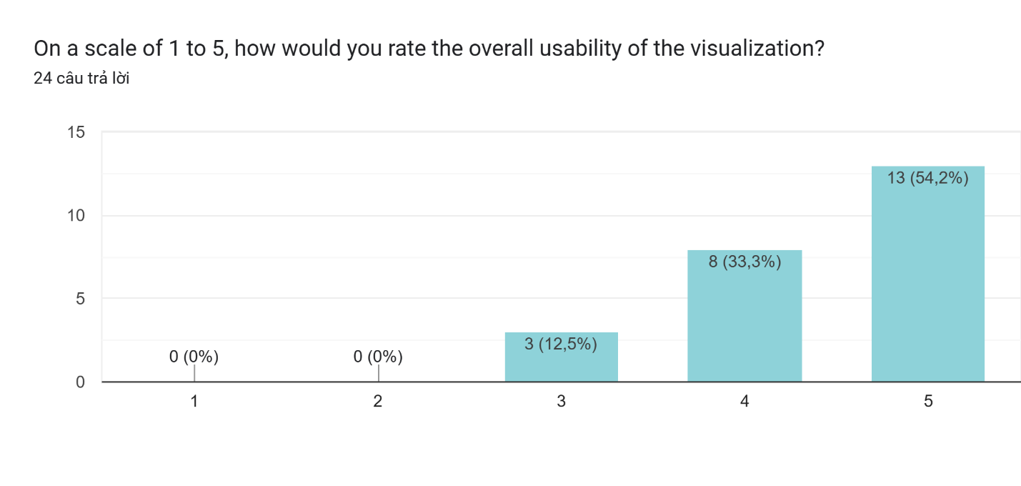 Figure 29: Users’ response usability

The responses indicate that the majority of participants found the overall usability of the visualization to be highly satisfactory. The highest percentage of participants, 54.2%, rated it as 5, indicating a high level of usability. Additionally, a significant portion of participants, 33.3%, rated it as 4, suggesting that they still found it to be quite usable.

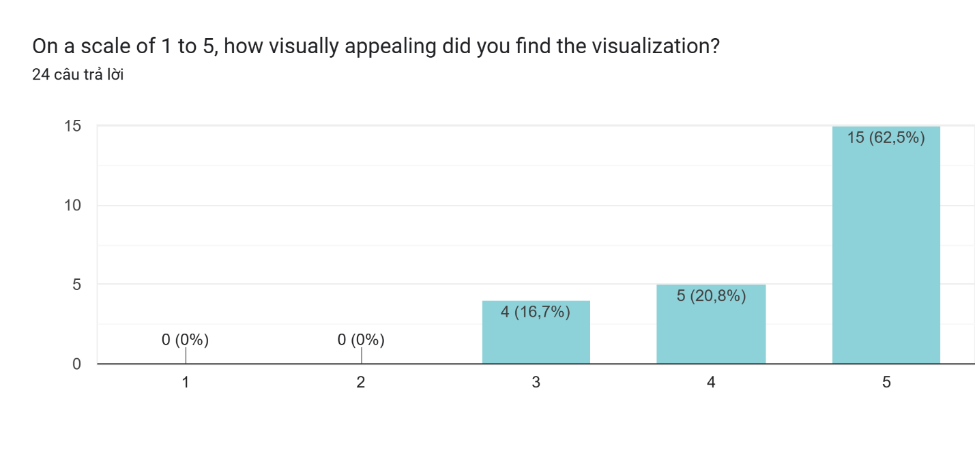

Figure 30: Users’ response to appearance

The majority of participants found the visualization to be visually appealing. The highest percentage of participants, 62.5%, rated it as 5, indicating a high level of visual appeal. Additionally, a significant portion of participants, 20.8%, rated it as 4, suggesting that they still found it visually appealing.

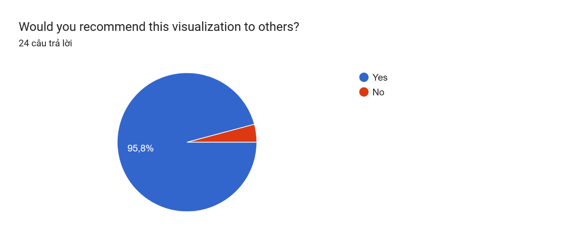

Figure 31: Users’ response to recommendation to others

Most of the participants would likely to recommend our visualization to others

# Conclusion

In today's globalized world, migration—especially cross-country migration—has become extremely common. There are pull and push factors at play in this trend. We extracted, processed, analyzed, and visualized the global migration to highlight the aforementioned phenomena. We selected two distinct kinds of diagrams. A world map is utilized to illustrate and contrast the migration flow, GDP per capita, and life expectancy; a line chart is employed to illustrate the variations in the migration numbers. The JavaScript D3.js library was used to plot the data. The essential features for both visualizations are interactive visualization, extra background information, a distinct data label, and contrasting colors for the various data points. Lastly, usability testing was done to make sure the visualization is easy to use, effectively conveys information, and meets the needs of the intended audience.

# References

Siddiqui, T. (2012). Impact of migration on poverty and development. Brighton: University of Sussex.

Hammar, T., Brochmann, G., Tamas, K., & Faist, T. (Eds.). (2021). International migration, immobility and development: Multidisciplinary perspectives. Routledge.

Castles, S. (2010). Understanding Global Migration: A Social Transformation Perspective. Journal of Ethnic and Migration Studies, 36(10), 1565-1586

Faist, T. (2013). The Mobility Turn: A New Paradigm for the Social Sciences? Ethnic and Racial Studies, 36(11), 1637-1646.

Zambotti, G., Guan, W., & Gest, J. D. (2015). Visualizing human migration through space and time. ISPRS Ann. Photogramm. Remote Sens. Spatial Inf. Sci.

Bertin, J. (2011). Semiology of graphics: Diagrams, networks, maps. Esri Press.

van Biljon, J., & Osei-Bryson, K. M. (2020). The communicative power of knowledge visualizations in mobilizing information and communication technology research. Information Technology for Development, 26(4), 637-652.

Sander, N., Abel, G. J., Bauer, R., & Schmidt, J. (2014). Visualising migration flow data with circular plots (No. 2/2014). Vienna Institute of Demography Working Papers.